*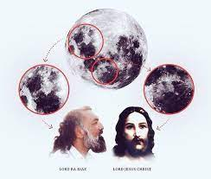mitochondria, anshi best known for converting nutrients into energy, also generate superoxide and hydrogen peroxide — redox signalling molecules that become harmful when overproduced. research reveals that such overproduction is not random, but rather occurs at a specific site in one*

*mitochondrial enzyme, opening the*

*door to targeted therapies for metabolic diseas***es .**

*door to targeted therapies for metabolic SDSD* diseases **.**

**Iphone15 ~~120000RS~~ BUT U GET IT AT 100000RS**

**H20 = WATER**

**22 = 4**

**MOVIES**

* **JURRASIC PARK**
* **FINAL DESTINATION**
* **JAAT**
* **9 RATING**
* **8 RATING**
* **7 RATING**

1. **WHICH VIRUS WAS AFFECT IN INDIA 2020?**
2. **CORONA**
3. **SWIN FLU**
4. **TYPHODE**

**2).WHERE IS SASANG GIR?**

**A.JUNGADH**

**B.JAMNAGAR**

**C.RAJKOT**

1. **XYZ**
2. **ABC**
3. **CDE**

**"Nature Thoery" is a SECONDARYBOARD concept referring to any Thoery that seeks to explain why the natural world is the way it is, encompassing various aspects like physical phenomena, the origins of things, and the fate of existence. It can be applied in fields like physics, biology, and even interdisciplinary studies. One prominent application of "nature Thoery" is within the "nature vs. nurture" debate, which explores the relative influence of genetics and environment on human traits and behaviors.**